**COS 20007**

**Task 3.1**

Duc Thuan Tran

*104330455*

1. **Code**
2. Counter.cs

using System;

namespace ClockClass

{

public class Counter

{

private int _count;

private string _name;

public string Name

{

get

{

return _name;

}

set

{

_name = value;

}

}

public int Ticks

{

get

{

return _count;

}

}

public Counter(string name)

{

_name = name;

_count = 0;

}

public void Increment()

{

_count ++;

}

public void Reset()

{

_count = 0;

}

}

}

1. Clock.cs

using System;

namespace ClockClass

{

public class Clock

{

private Counter _seconds;

private Counter _minutes;

private Counter _hours;

public Clock()

{

_seconds = new Counter("seconds");

_minutes = new Counter("minutes");

_hours = new Counter("hours");

}

public void Tick()

{

_seconds.Increment();

if (_seconds.Ticks == 60)

{

_seconds.Reset();

_minutes.Increment();

if (_minutes.Ticks == 60)

{

_minutes.Reset();

_hours.Increment();

if (_hours.Ticks == 24)

{

_hours.Reset();

}

}

}

}

public void Reset()

{

_seconds.Reset();

_minutes.Reset();

_hours.Reset();

}

public string DisplayTime()

{

return string.Format("{0:D2}:{1:D2}:{2:D2}", _hours.Ticks, _minutes.Ticks, _seconds.Ticks);

}

}

}

1. Program.cs

namespace ClockClass;

class Program

{

static void Main(string[] args)

{

Clock clock = new Clock();

while (true)

{

Console.Clear();

Console.WriteLine("Clock Time: " + clock.DisplayTime());

clock.Tick();

Thread.Sleep(1000);

}

}

}

1. **Image**
2. UML Diagram

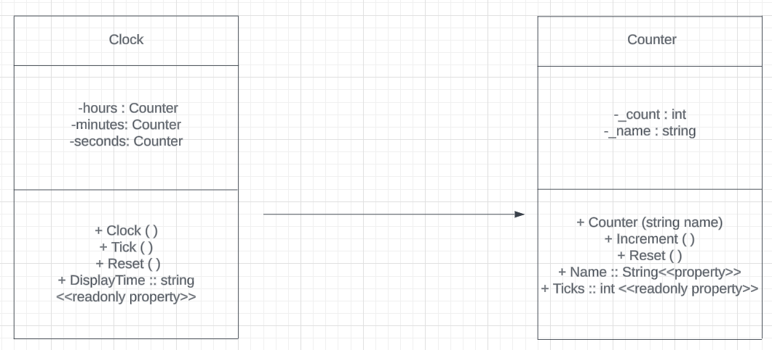

1. NUnit Test

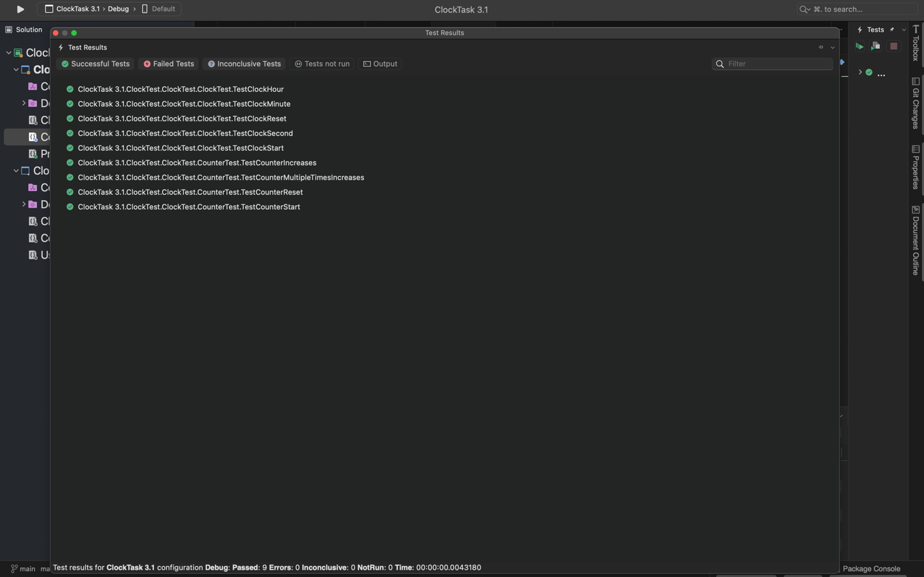

1. Program’s output

